**Plan2Value - Change Request Form**

1. **Title**

Unit Corrections and Initialize the version specific conversion factors

(this Change Request replaces the Initialize the version specific conversion factors)

1. **Description of Change**

During OMV’s testing of Aucerna Reserves unit conversions for different countries it was discovered that the conversion from Bbls to tonnes was not working correctly. After investigating the issue, Aucerna discovered a couple of errors in the configuration of the units in the OMV environment. This change request covers

1. Updating some base unit configuration data
2. Modifying a table to handle the conversion of condensate volumes to mass
   1. Changing the table structure
   2. Updating the Aucerna Reserves metadata associated with this table
3. Initializing the Factors tables with the latest values derived from values supplied by OMV
4. Update the PS Economic Loader to add in calculating BOE fuel volumes

The script initializes two reference tables that the loaders and reports use.  These two tables have been designed to be version specific as the values can change over time.   Since Catalin has created a new version in Prod, 2019 and rolled forward to 2020 these tables are currently empty.

The yearend rollover process will populate the table for the new versions on a go forward bases, but this script needs to be run on the initial version which was missed, so the script is required to be run once for 2019 and once for 2020.

In the Reserves process after the initial version is created, versions should really only be created by the rollover and copy version loaders in the application and not how the 2019 version was created, therefore eliminating the requirement of running this script in the future.

The values in the tables can be maintained by manual update by editing or adding new countries on the screens shown below.

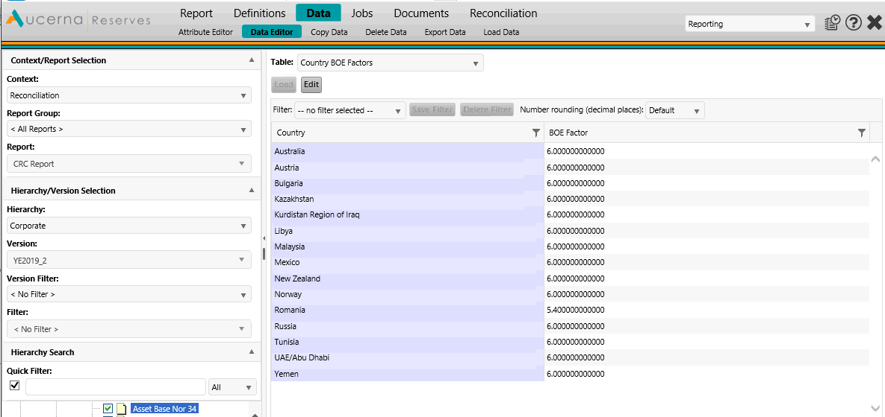

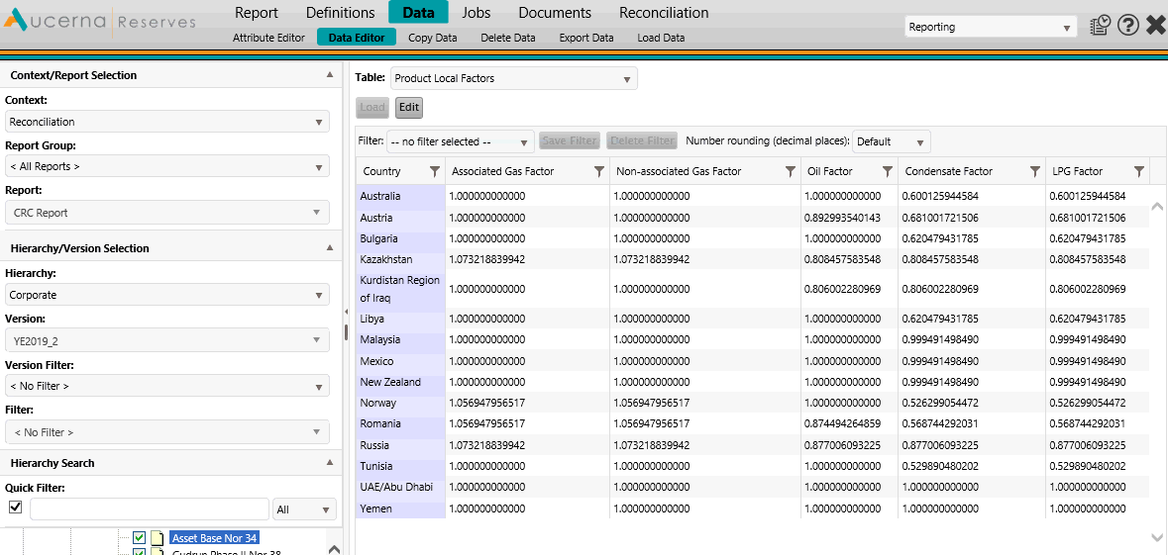

In addition to updating the refence data in the Factors tables the changes to the PS Economics loader. This update is required to ensure that the BOE volumes remain constant regardless of the country and local conditions. Previous the loader populated BOE Sales volume products for Gross and NEI. To get BOE Marketable volumes the fuel volume is required to be added to the BOE Sales. Problem was when reporting in Local units the Fuel gas volumes were converted to local conditions and then converted to BOE. This introduced a small difference in the BOE Marketable volume OMV was expecting. The change to the loader, now populates a BOE Fuel product which will remain constant no matter what the Local condition are.

OMV would also like to have three unit systems to be remove has as they are not using them and are confusing to end users. The following Unit systems are to be removed.

1. Field Local
2. Field Local (Tonnes)
3. Metric
4. **Implementation Steps**
5. Backup the database
6. Login to Aucerna Reserves
7. Go to the Data🡪Metadata🡪Metadata Import page
8. Browse to and upload the “OMV PLZ_PRODUCT_LOCAL_FACTORS metadata 20201020.xml” file
   1. Allow Overwrite of existing metadata should be checked and click the Import
9. Make sure the 2019 Reserves version has been created
   1. Go to Data🡪Data Versions🡪Version Definition
   2. If it is not created, create it (Catalin should know how to do this)
10. Login to SQL Server Management Server as a privileged user
11. Connect to the Production Aucerna Reserves database
12. Run contents of the SQL script file “OMV Factor Fix 20201020.sql”
13. From the SQL script file “OMV Initialize Factors 20201013.sql”, run the SQL script the statement below:

select * from PLZ_LINK_VW where CONTEXT_NAME = 'RECONCILIATION';

1. Replace 99999 with the LINK_ID from the above query for the 2019 version in the remaining portion of script “OMV Initialize Factors 20201020.sql” file
2. Run the queries
3. Follow the directions in the OMV Reserves Deployment 20201102.docx for the upgrade to the PS Economic loader
4. Go to the Configuration🡪Unit🡪Systems page
5. Click the edit
6. Click on the Manage Systems
7. From the list on systems,
   1. select Field Local, and click on Remove
   2. select Field Local (Tonnes), and click on Remove
   3. select Metric, and click on Remove
8. Click on Ok
9. Click Save
10. Restart all the Production App Pools and Agent
11. **Test Steps**
12. Log on to Aucerna Reserves
13. Go to the Reporting🡪Data🡪Data Editor page
14. Select the 2019 Version
15. From the Table drop down select Product Local Factors
16. Click the Load button
17. Values should appear and there should also now be a Condensate Factor column
18. From the Table drop down select Country BOE Factors
19. Click the Load button
20. More values that just Default should appear
21. Go to the Configuration🡪Units🡪Systems page
22. Scroll down to Unit Category “Volume- Liquid”, the Metric Local (Tonnes) line should have ktonne and not ktonnes

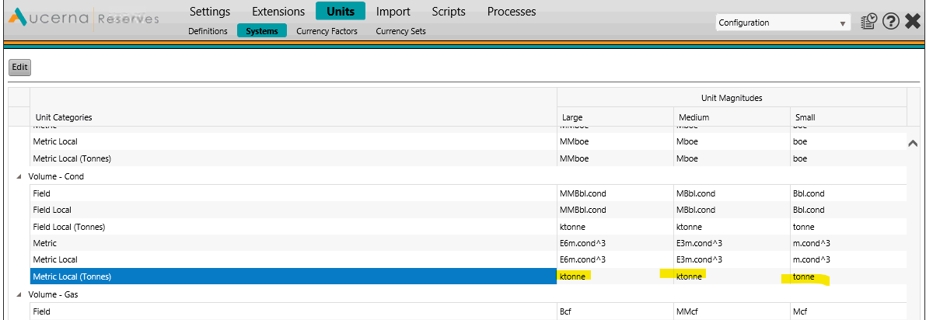

1. Go to the Configuration🡪Settings🡪Settings page
2. Select Reconciliation from the Context dropdown
3. The Settings should look like:

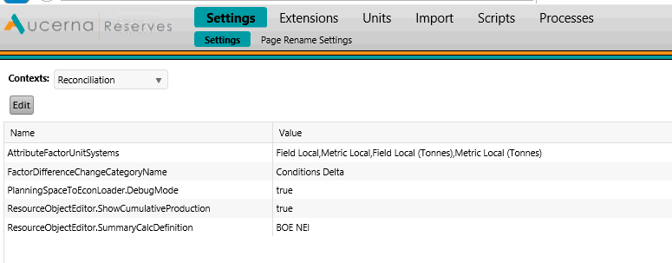

1. **Affected Modules and Interfaces**

Please tick below the relevant boxes and provide details if the case:

Dataflow (mapping template, report)

Economics (regime, report)

Financials

Portfolio

Reserves

Interface Reports

Details: PowerBI report

Interface Tools

Details: n/a

1. **Outage Plan**

Please tick below the relevant boxes and provide details if the case:

No

Yes

1. **Back-out Plan**

Please tick below the relevant boxes and provide details if the case:

No

Yes

* Details: Restore the database backup prior to the change.

1. **Approval**

* P2V Core Team (Subject matter experts)
* OMV Application Owner